**1) Create a customized docker image by using Docker file.**

**Create a Project Directory**:  
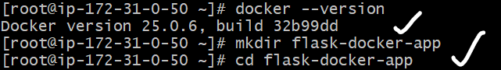  
**Create Your Flask Application**:  
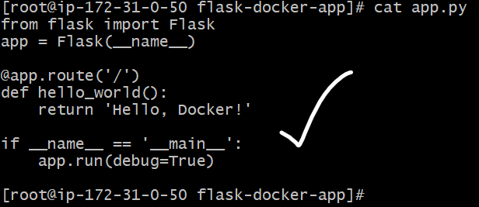  
**Add a requirements.txt File**:  
C:\Devops ScreenShots\Docker\extra3.png  
**Dockerfile:  
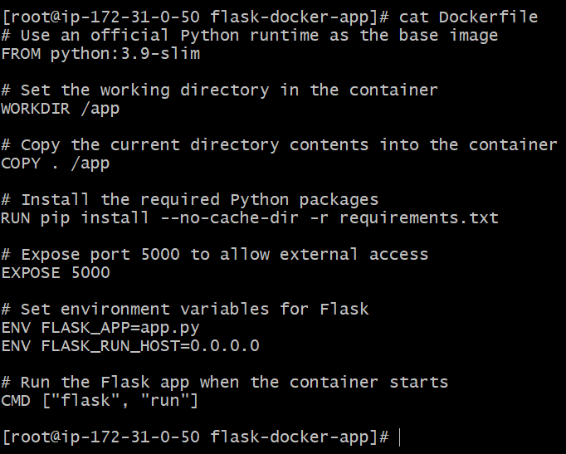**

**Build the Image**:  
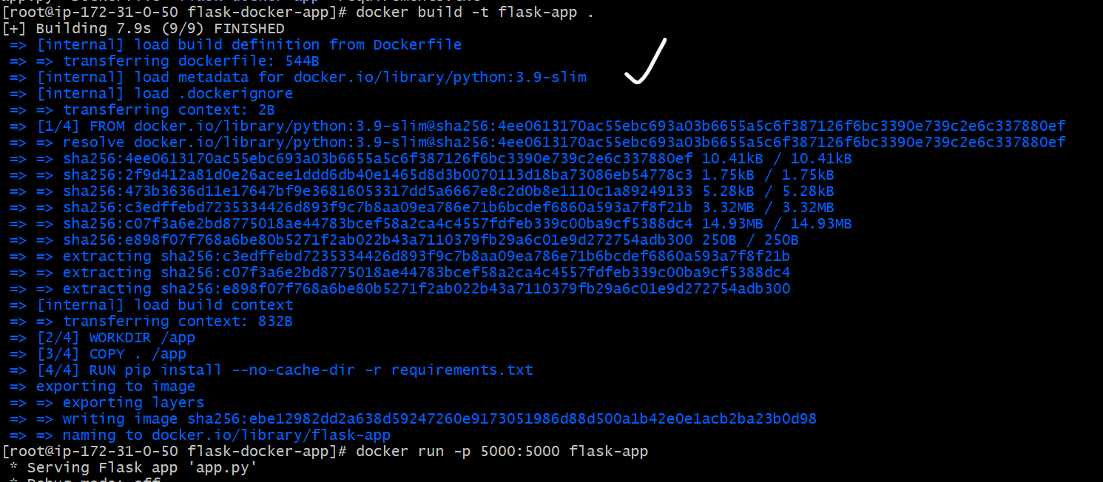  
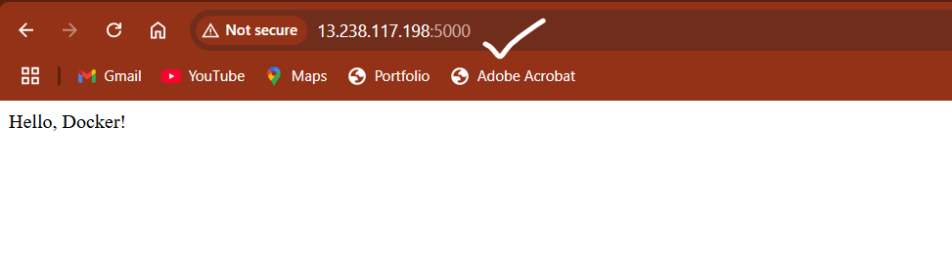

**2) Push the image to docker hub**

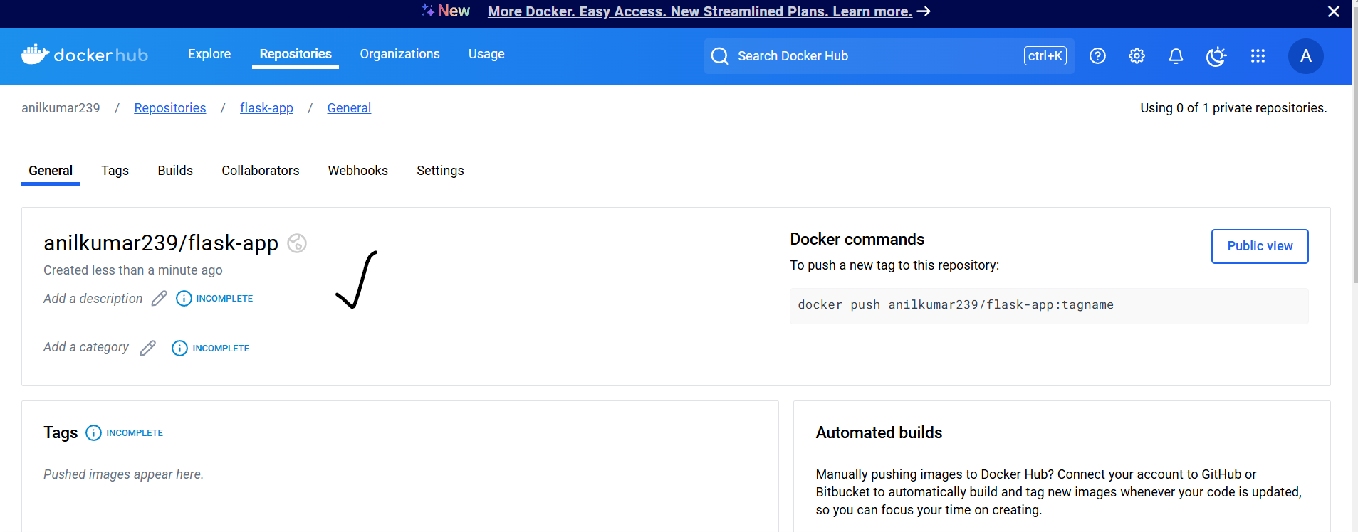

**3) Push the same Image to Amazon ECR**

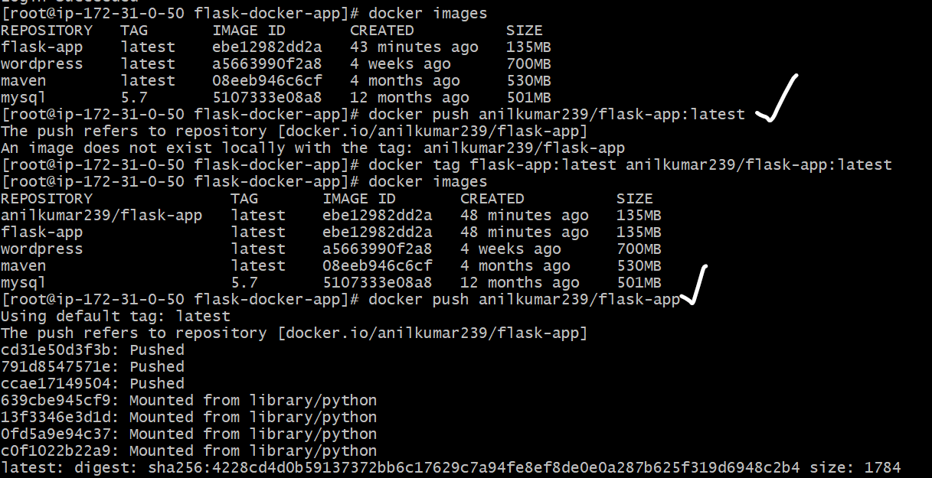

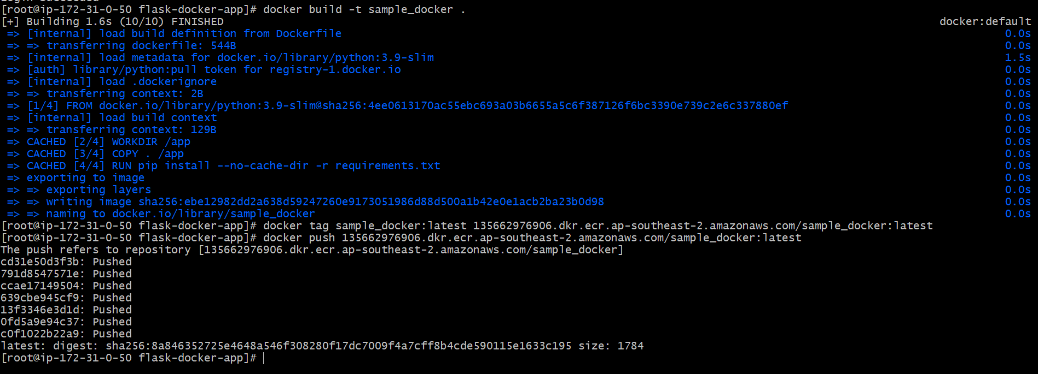

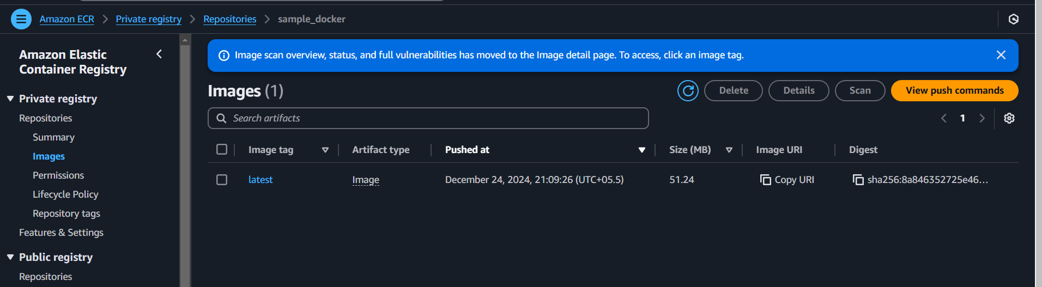

**4) Provision one ec2 using terraform and install Jenkins.**

resource "aws_instance" "jenkins_server" {

  ami           = "ami-0d6560f3176dc9ec0"

  instance_type = "t2.micro"

  key_name      = "docker"

  tags = {

    Name = "Jenkins-Server"

  }

  user_data = <<-EOF

              #!/bin/bash

              sudo yum update -y

              sudo amazon-linux-extras enable java-openjdk11

              sudo yum install -y java-11-openjdk

              sudo curl -fsSL https://pkg.jenkins.io/redhat-stable/jenkins.io.key | sudo tee /etc/pki/rpm-gpg/RPM-GPG-KEY-jenkins

              sudo sh -c 'echo -e "[jenkins]\nname=Jenkins-stable\nbaseurl=http://pkg.jenkins.io/redhat-stable\ngpgcheck=1\ngpgkey=https://pkg.jenkins.io/redhat-stable/jenkins.io.key\nenabled=1" > /etc/yum.repos.d/jenkins.repo'

              sudo yum install -y jenkins

              sudo systemctl start jenkins

              sudo systemctl enable jenkins

              EOF

  vpc_security_group_ids = [aws_security_group.jenkins_sg.id]

}

resource "aws_security_group" "jenkins_sg" {

  name        = "jenkins-sg"

  description = "Allow HTTP and SSH access"

  ingress {

    from_port   = 22

    to_port     = 22

    protocol    = "tcp"

    cidr_blocks = ["0.0.0.0/0"]

  }

  ingress {

    from_port   = 8080

    to_port     = 8080

    protocol    = "tcp"

    cidr_blocks = ["0.0.0.0/0"]

  }

  egress {

    from_port   = 0

    to_port     = 0

    protocol    = "-1"

    cidr_blocks = ["0.0.0.0/0"]

  }

}

output "jenkins_server_ip" {

  value = aws_instance.jenkins_server.public_ip

}

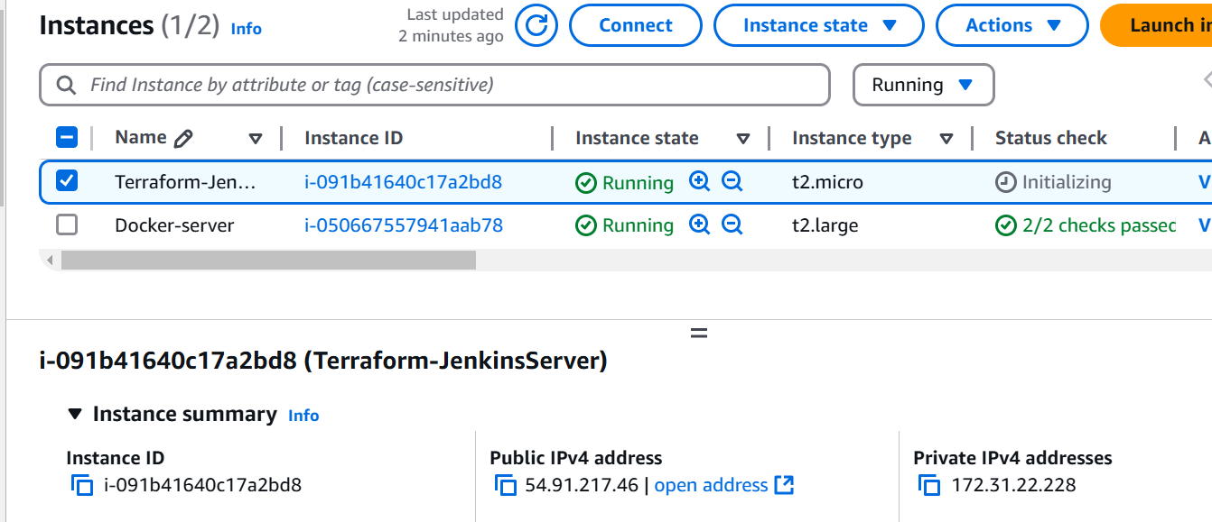

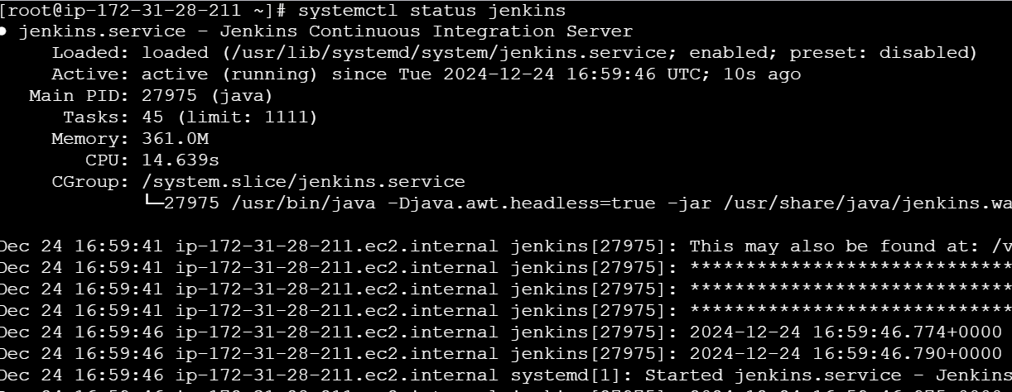

**5) Create One Jenkins job to Build and push the Docker image to Docker Hub. (**[**https://github.com/betawins/Python-app.git**](https://github.com/betawins/Python-app.git)**)**

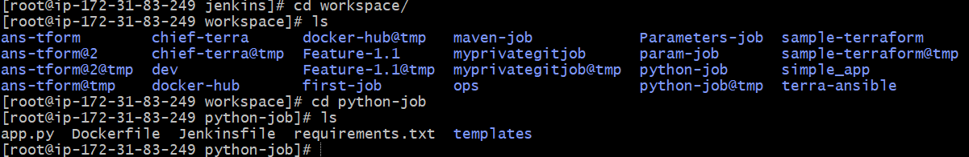

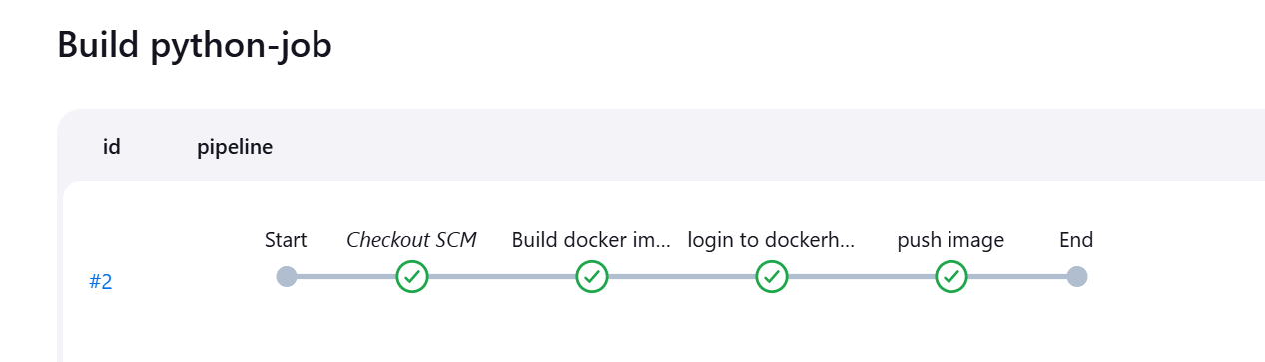

**1. From the source code of the frontend, Using that write a Docker file & build a docker image, run & push that image to your docker registry**

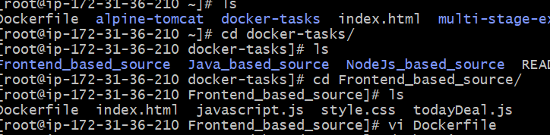

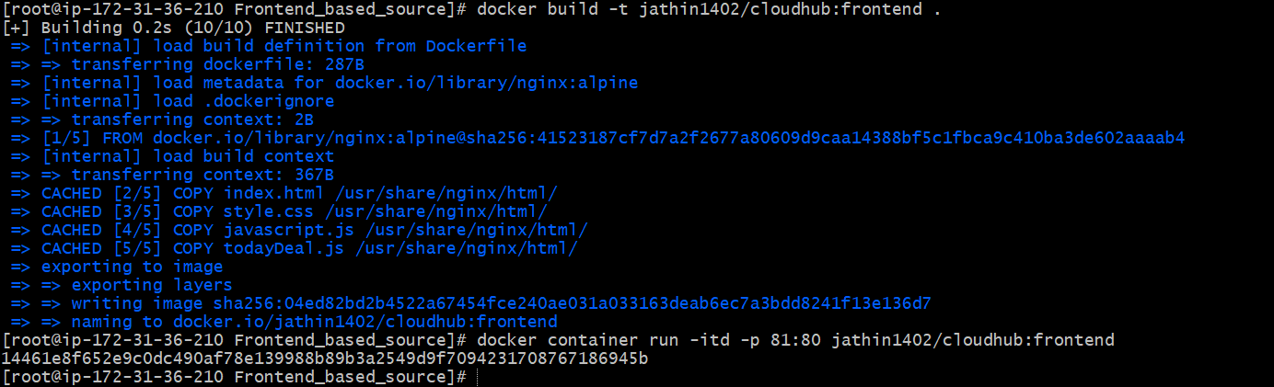

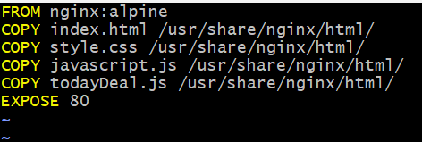



**2. From the Java Based Source Code, Write a Docker file, build, run & push to docker registry.**

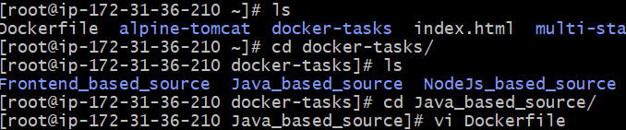

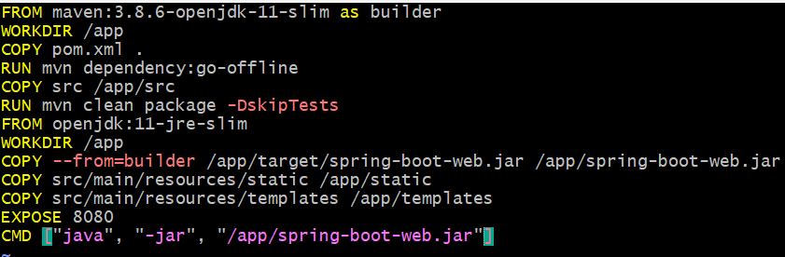

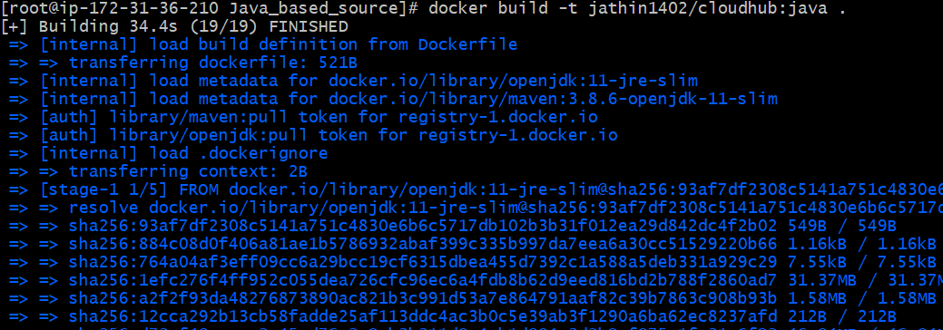

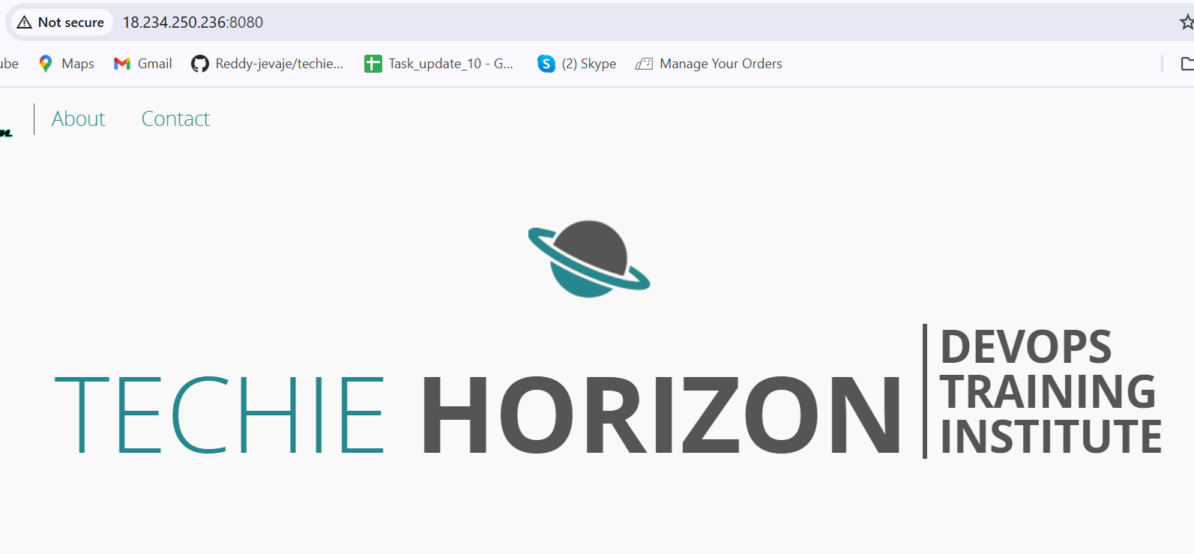

**3. From the NodeJS Based Source Code, Write a docker file, build with tag v1, run & push to docker registry.**

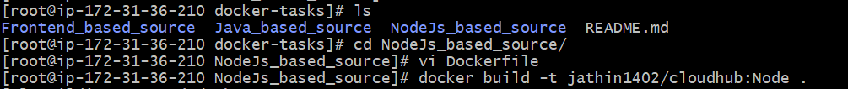





**4. Write a docker-compose docker file to setup WordPress with MySQL database**



